**Day 4 : 14 Sep 2024**

Verify the PostGres SQL Database in VM

C:\Program Files\PostgreSQL\16\bin

psql -U postgres

password : provide your password password in VM 123

\list to check all database present in your account.

create database testdb; it is use to create the database.

\c testdb; it is use to switch inside testdb database.

create table product(pid int primary key,pname varchar(50), price float);

insert into product values(1,'TV',67000);

insert into product values(2,'Computer',45000);

select * from product;

mkdir express-product-restapi-with-postgres

cd express-product-restapi-with-postgres

npm init or npm init -y

npm install express pg

pg -🡪 for post gres database

mysql 🡪 for mysql database

mongodb-🡪 mongo db database.

pg is one the external third party module which provide set of api which hep to connect postgres sql database using node js

Creating express js application using MVC style

config --🡪Folder 🡪dbConfig.js which contains database connection details.

repository -🡪Folder (contains more than one file which contains database related code). 🡪ProductRepository, OrderRepository, AccountRepository, LogingRepository etc.

these file import or load dbConfig file and get the reference of Pool and do the operation on table etc.

controller -🡪 folder (it is responsible to receive the value from routing file). Base on controller method it call respective repository method and return result to router file. Controller contains request and response object. ProductController, OrderController, AccountController, LoginController

router -🡪 folder , this file routing the request base upon http method and sub path and it pass the request to controller method. router.js (generic file), productRouter.js, orderRouter.js etc.

app.js or main.js

this file responsible to load required module like express or middleware module like cors etc

then provide the main path for the application and redirect the request to router file base upon the main path.

It provide listener details ie port number and host name.

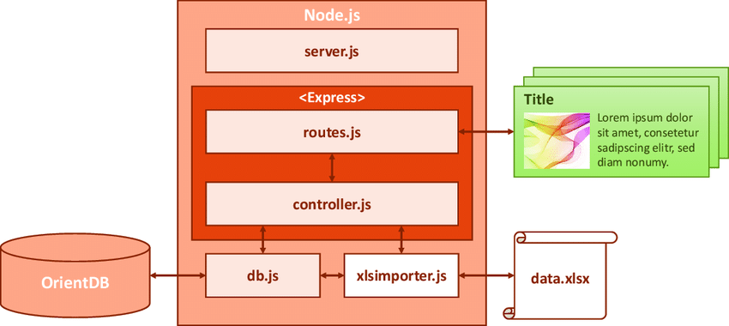

mkdir express-mvc-postgres-pg

cd express-mvc-postgres-pg

npm init -y this command is use to create package.json file

npm install express pg (pg like jdbc )

nodemon this module is use to refresh the application whenever we do any changes in the application. This module is third party modules we need to installed globally.

npm install nodemon -g

nodemon app.js

middleware modules

these modules add in between client and server modules. Whenever client send the request to specific end point before each request to server we want to perform some task that time we can use different type of middleware modules.

These middleware modules are can pre defined or user defined or custom modules.

Syntax to user middleware module

let express = require(“express”);

let app = express();

app.use(middlewaremodulename);

bodyParser is one of the type of middleware module to extract the data from request body part

generally we need to use while using post or put or patch method.

creating custom modules.

mkdir custom-middleware-module

cd custom-middleware-module

npm init -y

npm install express